yum install gcc -y
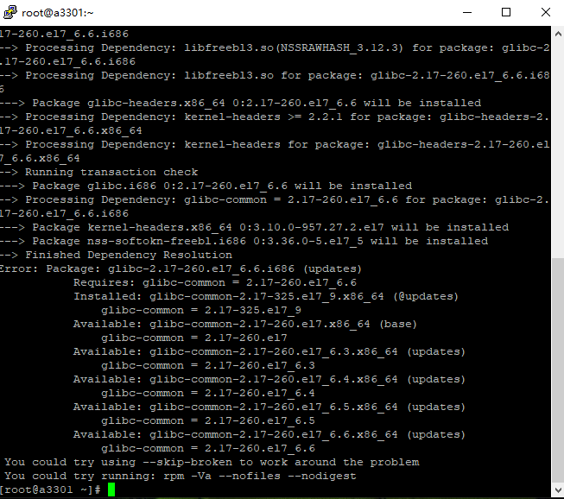

Error: Package: glibc-2.17-260.el7_6.6.i686 (updates)
Requires: glibc-common = 2.17-260.el7_6.6
Installed: glibc-common-2.17-325.el7_9.x86_64 (@updates)
glibc-common = 2.17-325.el7_9
Available: glibc-common-2.17-260.el7.x86_64 (base)
glibc-common = 2.17-260.el7
Available: glibc-common-2.17-260.el7_6.3.x86_64 (updates)
glibc-common = 2.17-260.el7_6.3
Available: glibc-common-2.17-260.el7_6.4.x86_64 (updates)
glibc-common = 2.17-260.el7_6.4
Available: glibc-common-2.17-260.el7_6.5.x86_64 (updates)
glibc-common = 2.17-260.el7_6.5
Available: glibc-common-2.17-260.el7_6.6.x86_64 (updates)
glibc-common = 2.17-260.el7_6.6
You could try using --skip-broken to work around the problem
You could try running: rpm -Va --nofiles --nodigest

Yum install python-devel -y

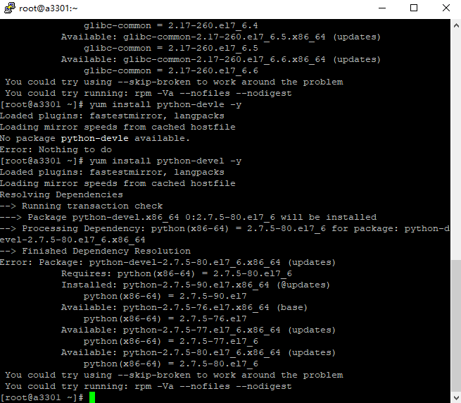
Error: Package: python-devel-2.7.5-80.el7_6.x86_64 (updates)
Requires: python(x86-64) = 2.7.5-80.el7_6
Installed: python-2.7.5-90.el7.x86_64 (@updates)
python(x86-64) = 2.7.5-90.el7
Available: python-2.7.5-76.el7.x86_64 (base)
python(x86-64) = 2.7.5-76.el7
Available: python-2.7.5-77.el7_6.x86_64 (updates)
python(x86-64) = 2.7.5-77.el7_6
Available: python-2.7.5-80.el7_6.x86_64 (updates)
python(x86-64) = 2.7.5-80.el7_6
You could try using --skip-broken to work around the problem
You could try running: rpm -Va --nofiles --nodigest

A32 정지 실패

